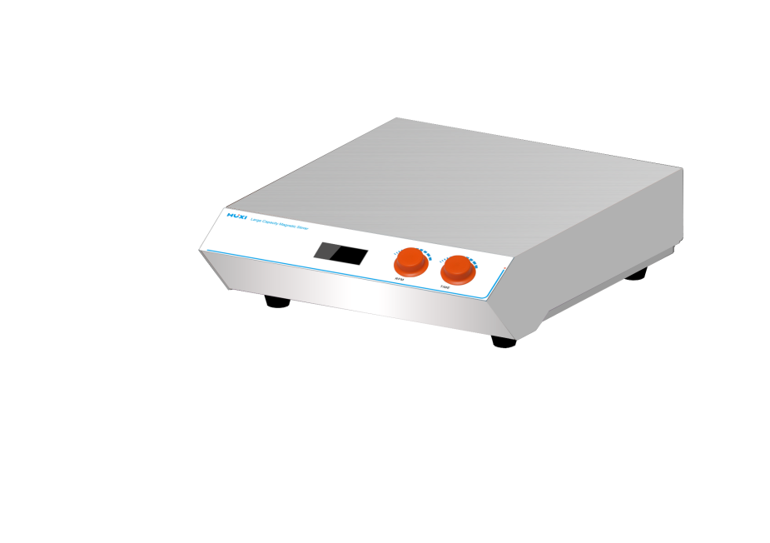

# **HMS-40 Large Capacity Magnetic Stirrer**

**Application：**

HMS-40 Magnetic Stirrer adopts the design of driving and stirring in one unit, which has a small footprint, easy and simple operation, and is suitable for chemical analysis, mixing of biological reagents, liquid treatment and other fields.

**Main Features：**

* Human waterproof design improves the safety of experimental operation, and the extra large working table can easily carry larger sample containers;
* LCD digital display real-time display of speed and time, real-time observation of experimental data, brushless motor, long life, maintenance-free, can run for a long time;
* Multiple stirring capacity for choice, to meet the needs of different experiments on sample processing;
* Simple knob design, can control the rotational speed, rotate to the left end is off, stepless speed adjustment mode, running without stuttering, save time and effort, easy to handle;
* Fully enclosed stainless steel shell, sturdy structure is not easy to deform, enough to withstand the weight of the maximum mixing capacity.

**Techncial Parameters：**

|  |  |
| --- | --- |
| Model | HMS-40 |
| Item No. | 1002032001 |
| Max.Capacity(L) | 40 |
| Model Type | Digital |
| Voltage (V) | 110-220 |
| Frequency(HZ) | 50~60 |
| Timer Range | 0-99h99min |
| Speed Range(rpm) | 100~1600 |
| Speed Display | LCD |
| Adjust Mode | Knob |
| Motor Type | Brushless motor |
| Motor Power(W) | 40 |
| Shell material | Stainless steel |
| Working plate material | Stainless steel |
| Allowable ambient humidity（%） | 80 |
| Allowable ambient temperature(℃) | 5-35 |
| Instrument Size(mm) | 440*360*140 |
| Packing Size(mm) | 640*475*240 |
| NW(kg) | 12.5 |
| GW(kg) | 15.5 |